ABSTRACT

The Student Record Management System using a singly linked list is a simplified, efficient application designed to store, manage, and manipulate student data dynamically. This system uses a singly linked list as the primary data structure to manage records, allowing for efficient insertion, deletion, and traversal operations. Each node in the list represents a student record containing fields such as student ID, name, age, department, and marks. The system supports essential functionalities such as adding new student records, displaying all records, searching for a specific student, and deleting records. By utilizing a linked list, the system ensures dynamic memory allocation and avoids the limitations of static data structures like arrays. This project demonstrates the practical application of data structures in real-world scenarios and helps in understanding memory management, pointer operations, and data organization techniques.
ABSTRACT WITH POs AND PSOs MAPPING

CO5: BUILD A DATABASE FOR REAL TIME PROBLEM

ABSTRACT  The Student Record Management System using a singly linked list is a simplified, efficient application designed to store, manage, and manipulate student data dynamically. This system uses a singly linked list as the primary data structure to manage records, allowing for efficient insertion, deletion, and traversal operations. Each node in the list represents a student record containing fields such as student ID, name, age, department, and marks. The system supports essential functionalities such as adding new student records, displaying all records, searching for a specific student, and deleting records. By utilizing a linked list, the system ensures dynamic memory allocation and avoids the limitations of static data structures like arrays. This project demonstrates the practical application of data structures in real-world scenarios and helps in understanding memory management. | POs MAPPED  POS1-3  POS2-3  POS3-3  POS4-3  POS5-3  POS6-3  POS7-3  POS8-3  POS9-3  POS10-3  POS11-3  POS12-3 | PSOs MAPPED  PSOS1-3  PSOS2-3

Table of content

 | TITLE | PAGE NO
 | ABSTRACT  ABSTRACT WITH POs AND PSOs MAPPING | vi  vii
 | LIST OF FIGURE | x
 | LIST OF ABBREVATION | xi
1 | INTRODUCTION  - Introduction  - Purpose and Importance  - Objectives  - Project summarisation | 1  1  1  2  3
2 | PROJECT METHODOLOGY  2.1 Introduction to System Architecture  2.2 Detailed System Architecture Diagram | 4  4  6
3 | DATA STRUCTURE PREFERENCE  3.1 Explanation of why a list was chosen  3.2 Comoparison with other Data structure  3.3 Advantages and Disadvantages of using a DLL | 7  7  10  11
4 | DATA STRUCTURE METHODOLOGY  4.1 Singly LinkedList  4.2 Node Structure  4.3 Insetion ,Deletion | 14  14  15  16
5 | MODULES  5.1 Create the Students Record  5.2 Display All Record  5.3 Search A Record  5.4 Dsplay Singly Linked List Position  5.5 Modify Students Detail  5.6 Get students Details  5.7 Get Record Details  5.8 Get Position | 18  18  19  19  20  21  21  22  22
6 | CONCLUSION AND FUTURE SCOPE  6.1 Conclusion  6.2 Future Scope | 24  24  25
7 | RESULT AND DISCUSSION  7.1 Result | 26  26
8 | APPENDICES  APPENDIX A- Source Code  APPENDIX B- sourcecode (Codetantra format)  APPENDIX B-Output  REFERENCES | 27  28  29  32  33

LIST OF FIGURE

FIGURE NO FIGURE NAME PAGE NO
2.1 Architecture Diagram 6
LIST OF ABBREVATIONS

ABBREVATIONS

SLL - Singly linked list

I - Insertion

D - Deletion
CHAPTER 1

INTRODUCTION

INTRODUCTION
Student record management is an essential system for educational institutions, helping to organize, store, and retrieve student information effectively. Traditional record-keeping methods often rely on static data structures like arrays or manual documentation, which can be inefficient in handling dynamic data changes. A singly linked list offers a flexible, dynamic, and memory-efficient approach to managing student records.A singly linked list is a linear data structure where elements, known as nodes, are connected sequentially, with each node containing student details and a reference (or link) to the next node in the sequence. This structure eliminates the need for contiguous memory allocation, allowing institutions to efficiently manage student information without predefined size constraints.
  - PURPOSE AND IMPORTANCE
Student record management using a singly linked list provides a structured, efficient, and scalable approach to handling student data dynamically. This system is particularly useful in educational institutions where student information, such as names, IDs, grades, and attendance, needs to be frequently updated and accessed. Unlike static arrays, which require a predefined size, singly linked lists allow records to expand and contract as needed, making them memory-efficient and adaptable to changes. The purpose of this system is to ensure smooth data insertion, deletion, and retrieval while minimizing unnecessary memory usage and enhancing accessibility. Since each node in a singly linked list contains student details along with a pointer to the next record, navigating through the list becomes systematic and straightforward.
The importance of this approach lies in its ability to maintain organized records without excessive storage overhead, making administrative processes more effective. It optimizes search operations, allowing quick access to specific student details, which is essential for grading, attendance tracking, and academic planning. Additionally, it enhances data integrity by preventing fragmentation and redundancy, ensuring accurate and reliable record management. As institutions grow and student populations increase, singly linked lists provide a scalable framework that seamlessly adjusts to evolving academic needs. Implementing this data structure not only improves efficiency but also supports long-term adaptability, making student record management more streamlined and effective. Let me know if like more details on specific operations, such as sorting or searching within a singly linked list.
  - OBJECTIVES

- Students Record Management
- Efficient Data Handling
- User Friendly Interface
- Scalability
- Robustness
  - PROJECT SUMMARIZATION

The Student Record Management System is a software application developed to efficiently store, organize, and manage student information using a singly linked list data structure. Unlike static arrays, the singly linked list allows the system to dynamically allocate memory, which means student records can be added, deleted, or modified without worrying about memory limits or shifting elements. Each record typically contains important student details such as roll number, name, department, and marks. The system supports essential operations including insertion of new records at any position, deletion of records based on unique identifiers, searching for specific student details, updating existing records, and displaying all stored records in a structured manner. This approach ensures flexible and efficient management of student data, especially useful for educational institutions that frequently update their records. Moreover, the project demonstrates practical applications of linked lists, helping users understand the benefits of dynamic data structures in real-world scenarios. It can also be extended further to include features like sorting records, saving data to files, or integrating with databases for larger-scale management.
Insertion: New student records can be added at different positions within the linked list (beginning, end, or specific position), allowing flexible data entry.
Deletion: Student records can be removed based on unique identifiers like roll number, ensuring outdated or incorrect data can be easily deleted.
Search: The system can search for a student record by roll number to quickly retrieve specific information.

CHAPTRER 2

PROJECT METHODOLOGY

INTRODUCTION TO SYSTEM ARCHITECTURE
System architecture refers to the conceptual model that defines the structure, behavior, and more views of a system. It serves as a blueprint for both the system and the project developing it. In the context of the students record management system, the system architecture outlines how various components interact and work together to achieve the desired functionality.

2.1.1 High-Level System Architecture
The high-level system architecture for the phone directory application typically consists of several key components:

- User Interface (UI)
- Application Logic
- Data Management Layer

2.1.2 Components of the System Architecture

a. User Interface (UI)
The User Interface is the layer with which the end-users interact. It can be a Command-Line Interface (CLI) or a graphical user interface (GUI). The UI component handles user inputs and displays the results. The input handling is the processes user inputs such as adding, updating, deleting, and searching the employee details. The Output display shows the results of user actions, such as search results or confirmation messages.

b. Application Logic
The Application Logic is the core of the application where all processing is done. This layer handles the business logic of managing students

2.2 DETAILED SYSTEM ARCHITECTURE:

Include a diagram that visually represents the system architecture. The diagram should depict how each component interacts with the others. For example, it can show the User Interface sending requests to the Application Logic, which in turn interacts with the Data Management Layer and the Storage Layer.

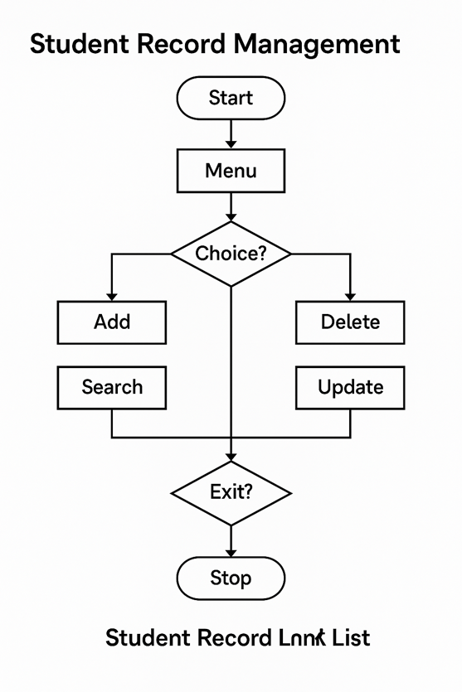
CHAPTER 3

DATA STRUCTURE METHODOLOGY

EXPLANATION OF WHY SINGLY LINKED LIST CHOOSEN?
A singly linked list is chosen for managing student records because it offers several advantages that suit the dynamic nature of student data. Unlike arrays, linked lists do not require a fixed size, allowing the system to efficiently handle any number of student records without wasting memory or facing size constraints. In a singly linked list, each student record is stored in a node that points to the next node, which makes insertion and deletion operations simple and fast. This is particularly useful when records need to be frequently added or removed, such as when new students enroll or existing records are updated. Additionally, linked lists allow easy traversal to access or search for specific records. The flexibility in memory allocation reduces fragmentation and overhead, making singly linked lists an ideal choice for applications like student record management where the data size varies over time and operations on records are common.

DYNAMIC NATURE
The dynamic nature of a singly linked list means that the data structure can grow or shrink as needed during program execution. Unlike arrays, which have a fixed size defined at the start, a singly linked list allocates memory for each student record node only when it is created. This allows the student record management system to handle an unpredictable and changing number of student entries efficiently. When a new student joins, a new node can be added anywhere in the list without shifting existing data. Similarly, when a student record needs to be deleted, the corresponding node can be removed easily without leaving gaps or requiring reorganization of the entire data structure. This flexibility makes singly linked lists well-suited for real-world applications like student record management where the total number of records is not fixed and changes frequently.
BIDIRECTIONAL TRAVERSAL
Bidirectional traversal means being able to move both forward and backward through a list of elements. In some data structures, like doubly linked lists, each node contains pointers to both the next and the previous node, enabling traversal in both directions.However, a singly linked list only contains a pointer to the next node, so it supports unidirectional traversal — moving forward from the head of the list toward the end. This means you cannot traverse backward because nodes do not have a reference to their previous nodes.For student record management, a singly linked list is often sufficient because most operations involve moving forward through the list (for example, when searching, inserting, or deleting). While bidirectional traversal can be useful, it adds extra memory overhead and complexity due to the additional backward pointers. Since student records typically don’t require backward navigation, the simpler singly linked list is a practical and efficient choice.
SIMPLICITY OF IMPLEMENTATION
One of the key reasons for choosing a singly linked list for student record management is its simplicity of implementation. A singly linked list is straightforward to design because each node contains only two parts: the student’s data and a pointer to the next node. This simplicity makes it easier to write, understand, and maintain the code compared to more complex data structures like doubly linked lists or trees, which require handling multiple pointers per node. For basic operations such as insertion, deletion, searching, and traversal, singly linked lists require fewer pointer adjustments, reducing the chances of errors. This makes singly linked lists especially suitable for beginners learning data structures or for projects where ease of development and clarity are important, like managing student records.
FLEXBILITY IN SORTING
Using a singly linked list for student record management provides flexibility in sorting the records based on different criteria such as roll number, name, or marks. Because the data is stored in nodes linked by pointers, the list can be easily rearranged by changing the links between nodes without physically moving the data itself. This pointer manipulation makes it efficient to implement various sorting algorithms (like insertion sort or merge sort) directly on the linked list. Unlike arrays, where sorting may require shifting elements in memory, linked lists allow the system to reorder records by simply updating node connections. This flexibility is useful when the institution needs to view or organize student data in different orders according to specific requirements, enhancing the usability of the record management system.
SPACE EFFICIENCY TRADE-OFF
When using a singly linked list to manage student records, there is a trade-off between space efficiency and the flexibility the data structure provides. Each node in a singly linked list stores not only the student’s data but also a pointer (or reference) to the next node. This pointer requires extra memory compared to simple arrays that only store the data itself. While this additional memory usage may seem like a drawback, it is balanced by the benefits of dynamic memory allocation—nodes are created only when needed, avoiding the wasted space that occurs in arrays when the allocated size is larger than the actual number of records. Thus, although singly linked lists use extra space per node due to pointers, they optimize overall memory usage by allowing the list to grow and shrink dynamically, making the trade-off worthwhile in applications like student record management where data site frequently changes.

3.2 COMPARISON WITH OTHER DATA STRUCTURE
When managing student records, the choice of data structure significantly affects the efficiency and scalability of the system. A Singly Linked List (SLL) is a linear data structure where each node contains student information (such as name, ID, marks) and a pointer to the next node. SLLs are easy to implement and allow dynamic memory allocation, which means new student records can be added without resizing. They perform well when the primary operations involve frequent insertions or deletions, especially at the beginning of the list. However, their main drawback is that they do not allow efficient searching or random access. To find a specific student, you must traverse the list from the head node, resulting in O(n) time complexity for search operations. Furthermore, since SLLs do not support backward traversal, navigating in revers requires additional overhead or design adjustmentarrays have a fixed size unless implemented dynamically, and inserting or deleting a record in the middle of an array requires shifting elements, which leads to O(n)

3.3 ADVANTAGES AND DISADVANTAGES OF USING A SLL
3.3.1 Advantages of Using a Singly Linked List
Using a Singly Linked List (SLL) in a student record management system offers several practical advantages, particularly in scenarios where flexibility and dynamic data hanmically. This means that as new student records are added or removed, the list can grow or shrink without the need for predefining a maximum capacity, unlike arrays that require a fixed size or costly resizing operations. This makes SLLs particularly well-suited for educational institutions where student enrollment numbers may fluctuate each term. Another important advantage is the efficiency of insertions and deletions. In an SLL, adding or removing a student record—especially at the beginning of the list—is a quick operation with a time complexity of O(1). This is beneficial in real-world systems where updates happen regularly, such as when new students register or existing ones leave.Moreover, singly linked lists are simple to implement, making them an excellent choice for developers building prototypes or educational tools. The straightforward nature of SLLs allows for quick development and easy debugging, which is useful in academic projects or small-scale deployments. Additionally, since each node only stores a reference to the next node, SLLs use less memory than doubly linked lists, which store two references per node. This lean memory usage becomes advantageous when managing hundreds or thousands of student records with limited system resources. The structure of an SLL also eliminates the problem of wasted memory found in arrays, where preallocated space might go unused. In contrast, with an SLL, memory is allocated only when needed, ensuring optimal use of resources .Another notable benefit is the ease of reordering records. If records need to be sorted—for example, by name, GPA, or student ID—this can be done by simply changing the pointers between nodes, without moving the actual data in memory. This makes the process more efficient than in contiguous memory structures. SLLs also lend themselves well to implementing stack- or queue-based features, such as waitlists for class registrations or helpdesk ticket queues, by simply manipulating the list's head and tail. Traversing an SLL to generate reports, calculate statistics like average grades, or export data is also relatively simple, even though it's linear in nature. Lastly, because each node is allocated individually and connected dynamically, singly linked lists help minimize memory fragmentation, especially in long-running applications where memory management is critical.they offer a robust, memory-efficient, and flexible solution for managing student records in systems where frequent updates and dynamic resizing are more important than high-speed lookup.dling are key. One of the main strengths of SLLs is their ability to allocate memory dyna .

3.3.2 Disadvantage of Using a Singly Linked List
While singly linked lists offer several advantages, they also come with notable disadvantages that can limit their effectiveness in a student record management system, especially as the system scales. One of the primary drawbacks is the lack of efficient searching and random access. In an SLL, accessing a particular student record requires sequential traversal from the head node, resulting in O(n) time complexity for search operations. This becomes inefficient when dealing with large numbers of student records, particularly if users frequently need to search by student ID or name. Unlike arrays or hash tables, where direct access is possible, singly linked lists provide no indexing mechanism, making them unsuitable for quick lookups.Another significant limitation is the inability to traverse backwards. Since each node only contains a reference to the next node, moving in reverse through the list is not possible without additional structures or modifications. This makes certain operations, such as reverse-order processing or backtracking, more complex and less efficient compared to doubly linked lists. Additionally, sorting a singly linked list is more complicated and time-consuming than with arrays, as rearranging elements involves modifying node pointers rather than simply swapping data values.Memory usage can also be a concern in certain contexts. While singly linked lists use less memory per node than doubly linked lists, each node still requires additional space for a pointer, which can add up in large datasets. Furthermore, singly linked lists do not take advantage of cache locality as arrays do, which can result in slower data access times due to increased cache misses during traversal. This may lead to performance degradation in time-sensitive applications.

CHAPTER 4

4.1 DATA STRUCTURE METHODOLOGY
4.1 SINGLY LINKED LIST
窗体底端
A singly linked list is an efficient way to manage student records in a dynamic system, as it allows flexible memory allocation and easy modifications. Each node in the list represents a student record and contains details such as the student's name, roll number, course enrolled, total marks, and a pointer to the next record. The system supports several fundamental operations including inserting new student records, searching for a student by roll number, deleting records, displaying all stored records, and updating existing details. The implementation ensures records are inserted in a sorted manner based on roll numbers and prevents duplication by checking for existing roll numbers before adding new entries. Additionally, exception handling is crucial to avoid errors and ensure data integrity. Overall, the use of a singly linked list offers an organized and efficient approach for managing student records dynamically, making retrieval and modification operations straightforward. Let me know if you need further clarification or coding assistance
Key Feature of a Singly Linked List
A student record management system using a singly linked list offers several key features that enhance efficiency and flexibility. It allows dynamic memory allocation, ensuring that records are stored without needing predefined limits. Each student record is represented as a node containing essential details such as name, roll number, course enrolled, total marks, and a pointer to the next record. The system supports efficient insertion, deletion, searching, and updating of student information while maintaining records in a sorted manner based on roll numbers. It also prevents duplication by verifying existing roll numbers before adding new entries. Exception handling is integrated to maintain data integrity and avoid errors. The adaptability of a singly linked list makes it ideal for handling student records dynamically, ensuring smooth retrieval and modification operations within the system. Let me know if you need further refinements

4.2 NODE STRUCTURE
In a student record management system using a singly linked list, the node structure plays a crucial role in maintaining efficient data organization and accessibility. Each node is designed to store essential student details such as the name, roll number, course enrolled, and total marks, ensuring a well-structured representation of student records. Additionally, the node contains a pointer that links to the next record, enabling dynamic storage without requiring contiguous memory allocation, unlike arrays. This structure facilitates quick insertion and deletion operations without unnecessary data movement, making the system highly flexible. The importance of this approach lies in its ability to maintain sorted records based on roll numbers, allowing for easy search and retrieval. It also supports seamless updates, as modifying student details can be done directly within the respective node without affecting surrounding records. Furthermore, exception handling mechanisms prevent duplication by verifying existing roll numbers before adding new entries, ensuring data integrity. The adaptability of the singly linked list enables efficient memory utilization, preventing wastage and optimizing performance. Overall, the node structure is fundamental to creating an organized, scalable, and responsive student record management system, ensuring smooth data handling and retrieval. Let me know if you need further refinements or coding assistance
4.3 INSERTION
Insertion in a student record management system using a singly linked list is a crucial operation that ensures efficient data organization and accessibility. When a new student record needs to be added, a new node is created and linked to the existing list while maintaining proper order based on roll numbers. The insertion process can be performed at different positions within the list, such as at the beginning, at the end, or in a sorted manner within the existing records. When inserting at the beginning, the new node becomes the head of the list and points to the previous first node, allowing quick access. Inserting at the end requires traversing the list until the last node is reached, where the new record is linked as the final node. Sorted insertion ensures that records remain in an ordered sequence, making retrieval and searching more efficient.duplication, ensuring consistency, and optimizing search operations. Before inserting a new record, a validation check is performed to verify that the roll number does not already exist, avoiding redundancy and maintaining data integrity. Additionally, dynamic memory allocation allows seamless addition of new records without predefined limits, making the system flexible for expanding student databases. Exception handling mechanisms prevent errors during insertion, ensuring smooth data management. Overall, a well-implemented insertion method in a singly linked list contributes to the system’s efficiency, making record management faster, adaptable, and reliable. Let me know if you need more details or code snippets
DELETION
Insertion in a student record management system using a singly linked list is a crucial operation that ensures efficient data organization and accessibility. When a new student record needs to be added, a new node is created and linked to the existing list while maintaining proper order based on roll numbers. The insertion process can be performed at different positions within the list, such as at the beginning, at the end, or in a sorted manner within the existing records. When inserting at the beginning, the new node becomes the head of the list and points to the previous first node, allowing quick access. Inserting at the end requires traversing the list until the last node is reached, where the new record is linked as the final node. Sorted insertion ensures that records remain in an ordered sequence, making retrieval and searching more efficient.The importance of maintaining a structured insertion method lies in preventing duplication, ensuring consistency, and optimizing search operations. Before inserting a new record, a validation check is performed to verify that the roll number does not already exist, avoiding redundancy and maintaining data integrity. Additionally, dynamic memory allocation allows seamless addition of new records without predefined limits, making the system flexible for expanding student databases. Exception handling mechanisms prevent errors during insertion, ensuring smooth data management. Overall, a well-implemented insertion method in a singly linked list contributes to the system’s efficiency, making record management faster, adaptable, and reliable. Let me know if you need more details or code snippets

CHAPTER 5

MODULES

5.1 CREATE THE STUDENTS RECORD
Function Name:insertion
Description: A student record in a singly linked list-based management system is designed to efficiently store and manage essential student details. Each student record is represented as a node containing key attributes such as name, roll number, course enrolled, total marks, date of birth, contact information, and address, ensuring comprehensive data storage. Additionally, each record maintains a pointer to the next node, allowing dynamic memory allocation and seamless traversal. The system supports efficient insertion, deletion, searching, and updating operations to facilitate easy record management. A validation mechanism ensures that duplicate roll numbers are not allowed, preserving data integrity. Exception handling techniques prevent errors during modifications, making the system robust and reliable. The linked structure enables flexible expansion without predefined size constraints, optimizing memory usage. With sorted insertion based on roll numbers, retrieval becomes faster, improving overall system efficiency. This approach allows seamless updates without affecting adjacent records, ensuring adaptability in managing student databases. Let me know if you need further refinements
5.2 DISPLAY ALL RECORDS

Function Name: displayQueue()

Description: Queue Implementation Using a Singly Linked ListA queue is a data structure that operates on the First In, First Out (FIFO) principle, meaning elements are added at the rear and removed from the front. When implemented using a singly linked list, each node contains data and a reference to the next node. This dynamic memory allocation approach eliminates the need for predefined size limits and allows efficient insertions and deletions in constant time.In this implementation, the enqueue operation inserts a new node at the rear, ensuring that elements are stored sequentially. The dequeue operation removes the front node, adjusting the pointer to maintain queue integrity. The peek function retrieves the front element without removing it, providing insight into queue status. Additionally, functions like isEmpty and getSize help in monitoring the queue's state.A queue implemented with a singly linked list is particularly useful when memory constraints prevent using a fixed-size array. It is widely applied in scheduling processes, task management, and buffering systems where data needs to be processed in the order of arrival.

5.3 SEARCH A RECORD
Function Name : searchRecord()
Description:A Student Record Management System is a digital solution designed to efficiently store, track, and manage student data within educational institutions. It eliminates manual record-keeping and reduces human errors by providing a centralized platform for handling student information, including attendance, grades, admission details, and disciplinary records. These systems often feature role-based logins, allowing students, parents, teachers, and administrators to access relevant data securely. Additionally, cloud-based functionality enables real-time access to student records from any location. By integrating analytics and behavior tracking, student record management software offers a comprehensive overview of each student’s academic performance and behavioral patterns, helping institutions make informed decisions. The adoption of such systems enhances efficiency, improves data security, and streamlines administrative processes, making it an essential tool for modern educational institutions.

5.4 DISPLAY SINGLY LINKED LIST POSITION
Function Name:displayPriorityPosition()
Description: Digital solution designed to efficiently store, track, and manage student data within educational institutions. It eliminates manual record-keeping and reduces human errors by providing a centralized platform for handling student information, including attendance, grades, admission details, and disciplinary records. These systems often feature role-based logins, allowing students, parents, teachers, and administrators to access relevant data securely. Additionally, cloud-based functionality enables real-time access to student records from any location. By integrating analytics and behavior tracking, student record management software offers a comprehensive overview of each student’s academic performance and behavioral patterns, helping institutions make informed decisions. The adoption of such systems enhances efficiency, improves data security, and streamlines administrative processes, making it an essential tool for modern educational institutions.

5.5 MODIFY STUDENTS DETAILS
Function Name:modifyStudentsDetails()
Description:A Student Record Management System using a singly linked list allows efficient modification of student details by dynamically updating nodes. In a singly linked list, each student record is stored as a node containing essential details such as name, roll number, course, and marks. To modify a student's details, the system first searches for the corresponding node using the roll number as a unique identifier. Once located, the node's data fields are updated with the new information while maintaining the linked structure. If the modification affects sorting order (e.g., updating marks in a sorted list), the node may need to be repositioned by unlinking it and reinserting it at the correct position. This approach ensures flexibility in handling student records without requiring excessive memory allocation or shifting elements, as seen in arrays. Linked list-based student management systems are widely used in educational software for efficient data handling and retrieval. You can explore more details about implementing such a system and learn about modifying nodes in a linked list
5.6 GET STUDENTS DETAILS
Function Name: getJobDetails()
Description:A Student Record Management System using a singly linked list efficiently stores and retrieves student details by dynamically managing nodes. Each student record is represented as a node containing essential information such as name, roll number, course, and marks. The linked list structure allows easy traversal, enabling quick access to student details without requiring contiguous memory allocation.To retrieve student details, the system iterates through the linked list, comparing the roll number or name with the search query. Once the matching node is found, the stored information is displayed. This approach ensures efficient data retrieval without requiring complex indexing mechanisms. Additionally, linked lists allow seamless insertion and deletion of records without shifting elements, making them ideal for dynamic student databases.

5.7 GET RECORD DETAILS
Funtion Name: getRecordDetails()
Description:Student record management is a crucial aspect of educational institutions, ensuring efficient tracking and organization of student data. It involves maintaining records related to personal information, academic performance, attendance, disciplinary actions, and extracurricular activities. Modern student management systems use digital databases to store and organize this data securely, allowing authorized personnel to access and update records when necessary. Additionally, student record management ensures compliance with educational policies and data protection laws, preventing unauthorized access to sensitive information. Automation and integration with other school systems enhance efficiency, enabling smooth academic evaluations, admissions, and progress monitoring. Proper management of student records not only streamlines administrative tasks but also helps educators and administrators make informed decisions to improve student outcomes.

5.8 GET POSITION
Function Name:getPosition()
Description : In student record management, a singly linked list can be used to efficiently store and manage student details while maintaining flexibility in adding, deleting, or searching records. A singly linked list consists of nodes, where each node represents a student's record and contains data fields such as student ID, name, grades, and attendance. Each node also has a pointer that links it to the next node in the list, allowing traversal in a forward direction.To retrieve a specific student's position in the list, traversal begins at the head node and proceeds sequentially through each node while comparing the required identifier (e.g., student ID). The position is determined by counting nodes until the desired student record is found. If the record does not exist, the traversal ends, indicating an unsuccessful search. This approach ensures dynamic memory allocation, efficient insertion, and deletion without requiring contiguous memory space like an array.

CHAPTER 6
CONCLUSION AND FUTURE SCOPE

6.1 CONCLUSION
The implementation of student record management using a singly linked list offers an efficient and dynamic approach to handling data. By utilizing nodes connected sequentially, this system allows easy insertion, deletion, and updating of student records without the limitations of static memory allocation. The flexibility of the singly linked list ensures that stoelyrage can be adjusted as needed, making it an ideal choice for managing student information dynamically. Furthermore, this structure supports traversal operations, enabling quick access to records while maintaining simplicity in implementation. Despite its advantages, considerations such as searching efficiency and potential performance improvements can be explored further to enhance overall usability. Ultimately, leveraging a singly linked list for student record management provides a structured yet adaptable framework for educational institutions to maintain and organize their data effectivly.

6.2 FUTURE SCOPE
The implementation of a student record management system using a singly linked list offers a foundational approach to handling dynamic data efficiently. Although it primarily caters to basic functionalities such as insertion, deletion, and traversal of student records, there are several opportunities for future enhancement and application. As educational institutions increasingly adopt digital solutions, this system can evolve into a more comprehensive platform. Future development may include integration with databases to support persistent storage and larger datasets, incorporation of user authentication to secure sensitive information, and the addition of search and sorting algorithms to optimize performance. Furthermore, the system can be expanded with a graphical user interface (GUI) to improve usability for administrative staff and faculty. In the realm of data analysis, integrating analytics features to track student performance trends over time could significantly aid academic planning and decision-making. Overall, the basic singly linked list structure lays the groundwork for scalable, real-time student data management solutions that can adapt to the growing demands of modern education systems.
Database Integration: Transition from in-memory storage to database systems like MySQL or MongoDB for persistent and scalable data handling
Security Features: Include login/authentication systems to protect student data and ensure only authorized access.
Data Analytics: Add functionality to analyze student performance, attendance trends, and academic progression using statistical tools.
File Handling: Enable saving and loading student records from files (CSV, JSON, etc.) to support offline access and backups.
Modular Design: Break down the system into modules for easier maintenance, testing, and future upgrades.

CHAPTER 7

RESULT AND DISCUSSION

7.1 RESULT
Result of Student Record Management System Using Singly Linked List
The implementation of the student record management system using a singly linked list has successfully demonstrated the fundamental concepts of dynamic data handling. The system allows for efficient insertion, deletion, and traversal of student records without the need for pre-allocated memory, showcasing the flexibility of linked lists. Through this project, basic operations such as adding new student data, removing records, and displaying information were executed effectively. The system also highlights the advantages of using linked lists over static data structures like arrays, especially in scenarios where the number of records changes frequently. Overall, the project served as a practical demonstration of data structure concepts in a real-world application and laid the groundwork for more advanced features and enhancements in the future.

窗体底端
APPENDICES

APPENDIX A - SOURCE CODE

#include <stdio.h>
#include <stdlib.h>
#include <string.h>
Struct Student{
int id,age;
float marks;
char name[50];
Struct Student*next;
}*head = Null;
void add(int id,char name[ ],int age,float marks) {
Struct student*s=malloc(sizeof(struct student));
S->id = id; s->age = age;s->marks = marks;
Strcpy(s->name,name);
s->next = head;
head = s;
}
void show() {
Struct student*t = head;
printf(“\n Id Name Age Marks\n”);
while (t) {
printf(“%d %-10s %d %.2f\n”,t->id,t->name,t->age,t->marks);
t = t->next;
}
}
int main() {
add(1,”Alice,20,85.5);
add(2,”Bob”,21,78.0);
add(3,”Charlie”,19,92.3);
show()
return 0;
}

APPENDIX B - SCRENSHOT

CREATE A STUDENTS RECORD

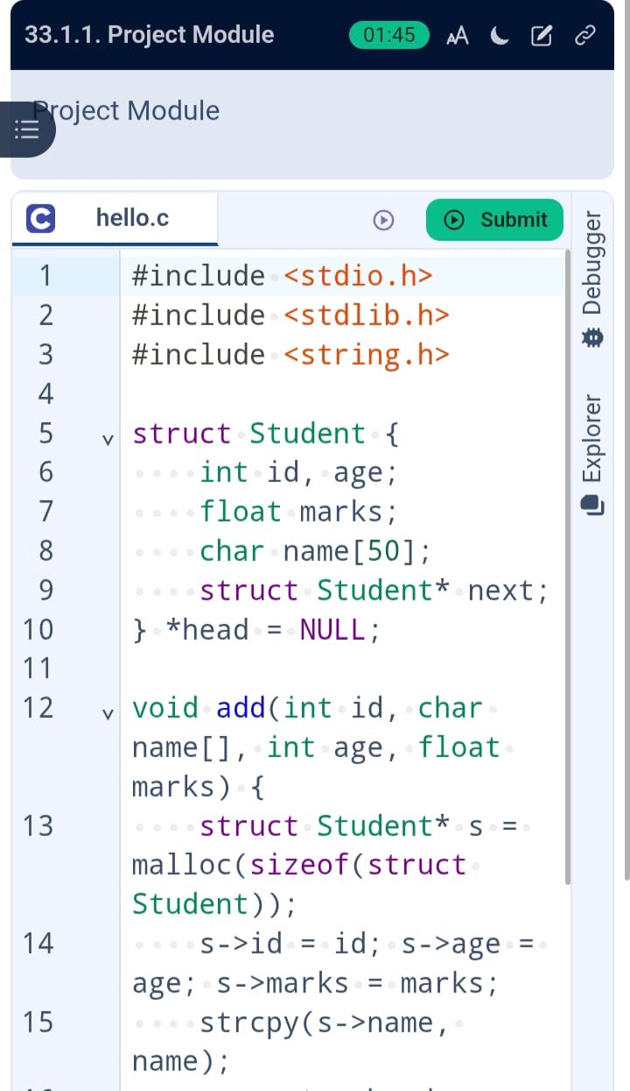

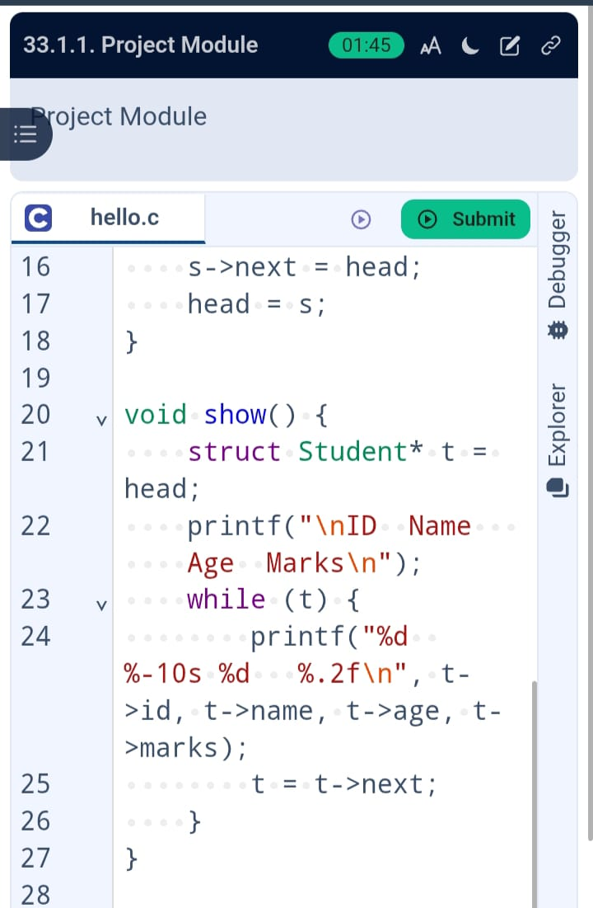

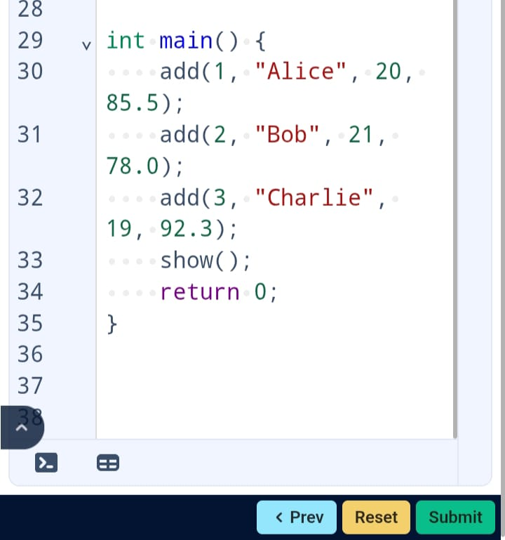
窗体顶端
OUTPUT:

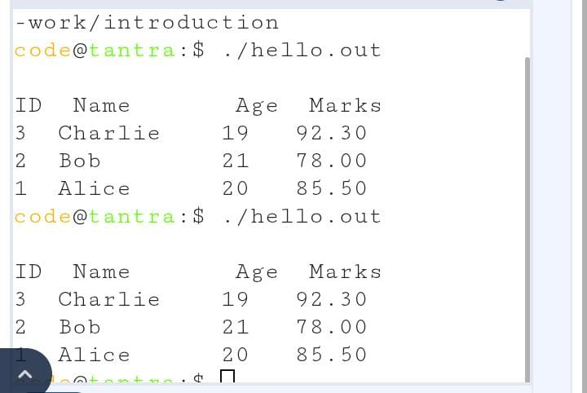

REFERNCES
E. Balagurusamy
Title: "Programming in ANSI C"
Publisher: McGraw Hill
Details: Covers linked lists, pointers, and structured programming techniques—ideal for student record systems.
Use in Project: Reference for linked list implementation logic.
Yashavant Kanetkar
Title: "Let Us C"
Publisher: BPB Publications
Details: Chapter on Linked Lists demonstrates basic list structures, ideal for record management examples.
Use in Project: For designing and inserting records using singly linked lists.
Mark Allen Weiss
Title: "Data Structures and Algorithm Analysis in C"
Publisher: Pearson
Details: Offers deep insights into linked lists, memory management, and efficient data handling.
Use in Project: For efficient list traversal and memory handling.

